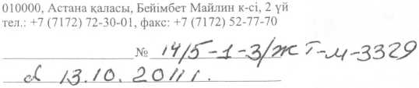
КЫЛМЫСТЫК - АТКАРУ ЖУЙЕС1Н1Ц КОМИТЕТ!
KAZAKHSTAN REPUBLICAS
1SHK1 ICTEP
MINISTRL1P

DI Y g ■ G
MINISTRY OF
INTERNAL AFFAIRS
OF THE REPUBLIC OF KAZAKHSTAN
COMMITTEE
CRIMINAL PRINCIPAL
SYSTEM
010000, Astana, Beimbet Mailina street, building 2 tel.: +7 (7172) 72-30-01, fax: +7 (7172) 52-77-70

Mr. Mamedov M. B.
050059, Almaty st. Furmanova 240 post office No. 59, PO Box No. 2
Having considered your appeal regarding confirmation or denial of the fact of visiting penal institutions, we inform you as follows.
According to information received from the territorial divisions of the penal system, it is not possible to confirm or deny the fact that you visited penal institutions on the indicated dates, since in some correctional institutions the visitor logs were destroyed due to the expiration of storage periods.
At the same time, in accordance with the certificate on the personal file, the convicted Dzhamanaev S.K. arrived at the pre-trial detention center in Almaty on April 22, 2009. At the same time, according to the available accounting data, on November 21, 2009, you did not visit pre-trial detention centers in Almaty.
Chairman

T. Ahmetov

Spanish: Galiev A. tel.: 72-30-28

